**Project Design Phase-II**

**Data Flow Diagram & User Stories**

|  |  |
| --- | --- |
| Date | 12 October 2022 |
| Team ID | PNT2022TMID09766 |
| Project Name | Project - **Real -Time Communication System Powered By AI For Specially Abled** |
| Maximum Marks | 4 Marks |

**Data Flow Diagrams:**

A Data Flow Diagram (DFD) is a traditional visual representation of the information flows within a system. A neat and clear DFD can depict the right amount of the system requirement graphically. It shows how data enters and leaves the system, what changes the information, and where data is stored.

**Example: (Simplified)**

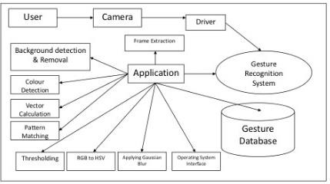

Example:

DFD

Level

0

(

Industry

Standard)

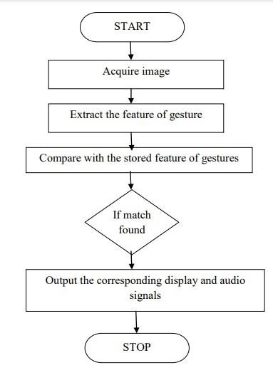

**User Stories**

Use the below template to list all the user stories for the product.

|  |  |  |  |  |  |  |
| --- | --- | --- | --- | --- | --- | --- |
| **User Type** | **Functional**  **Requirement (Epic)** | **User**  **Story**  **Number** | **User Story / Task** | **Acceptance criteria** | **Priority** | **Release** |
| ***Customer***  *(Desktop user)* | Registration | USN-1 | **Not Required** | I can access my account / dashboard | High | Sprint-1 |
|  | **Login** | USN-2 | **Not Required** |  | High | Sprint-1 |
|  | **Dashboard** | USN-3 | **Not Required** |  |  |  |
| ***Customer***  *(Desktop user)* | **Main page** | USN-4 | As a User, **I can enter the web page once clicked, which provides be the Guidelines** to use the app | I can **enter the web page** once clicked | Medium | Sprint-1 |
| *Customer*  *(Desktop user)* | **Guidelines** | USN-5 | As a User , **I can give a read through the guidelines to understand the functioning of the app.** | I can **give a read through the guidelines.** | Medium | Sprint-1 |
| ***Customer*** *(Desktop user)* | **Convert Sign** | USN-6 | As a User, **I can click the button Convert sign** , which directs me towards the Main screen | I can **click the button Convert sign and directed me to main screen.** | Medium | Sprint-2 |
| ***Customer*** *(Desktop user)* | **Camera(Hand movement detection)** | USN-7 | As a User, **I can show my hand sign towards the camera which converts them into text manner.** | **I can show my hand sign** towards the camera accurately. | High | Sprint-2 |
| ***Customer*** *(Desktop user)* | **Voice mode** | USN-8 | Once the text is obtained, As a User **I can click on the voice mode which provides the text in the form of speech.** | **I can click on the voice mode** which provides the text in the form of speech. | High | Sprint-2 |
| ***Customer Care Executive*** | **Provide the necessary functionalities required to use the app.** |  | As an Executive, I can **provide the Specifications of Camera required, and other factors** that are required for smooth functioning of the app. | **I can provide the**  **Specifications** of Camera required, and other factors | Low | Sprint-1 |
| ***Customer Care Executive*** | **Check the performance of the app** |  | As an Executive, I can **check the usage and queries obtained from the end users**. | I can **check the usage and queries** obtained from the end users. | Medium | Sprint-1 |
| ***Administrator*** | **Receive queries based on the usage** |  | As an Admin, I can **take the queries from the customer care and perform the testing phase again , loading the other signs in the dataset**, in order to make the customers to use the app effectively. | I can **take the queries from the customer care and perform necessary phases again.** | High | Sprint-2 |